Excellence in Graduate Research

This award is presented to graduate and professional students who have received national and/or international recognition in their field and show promise in their area of research and/or creative achievement.

Awardees:
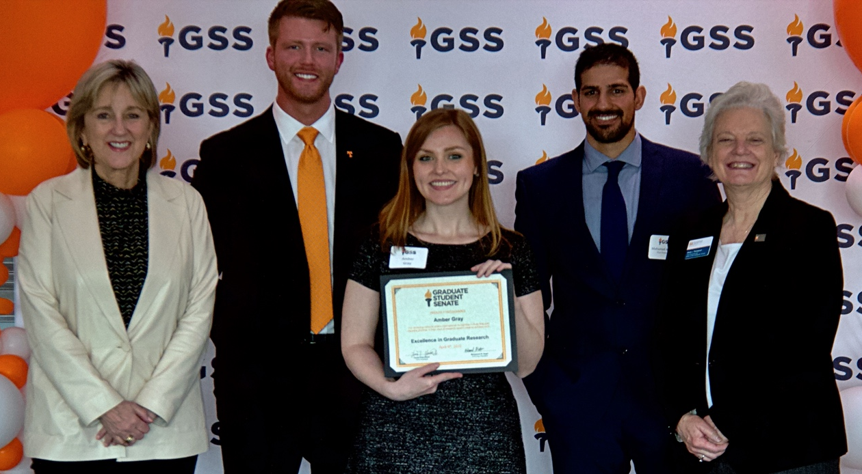

Amber Gray – PhD student in the Department of Chemistry. Amber's research involves the investigation of small amyloid oligomers, which are notorious in their association of many human diseases such as Alzheimer's Disease and Type II Diabetes. Amber has four peer-reviewed first author or co-first author publications in high impact journals. Additionally, she has been the recipient of several awards and fellowships, such as the Analytical Chemistry Summer Fellowship granted by Eastman Chemical Company.
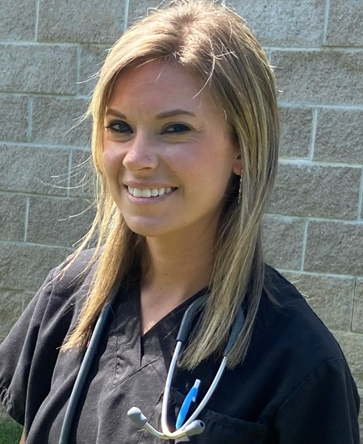

Ashley Reeves – PhD student in Veterinary Medicine. Ashley is investigating assisted reproductive protocols in free-ranging ocelots, a wild feline species, in Texas. She has delivered 11 presentations on various studies and has received first place in People’s Choice and Special Director’s awards from The East Foundation at Texas A&M in 3-minute thesis competitions.
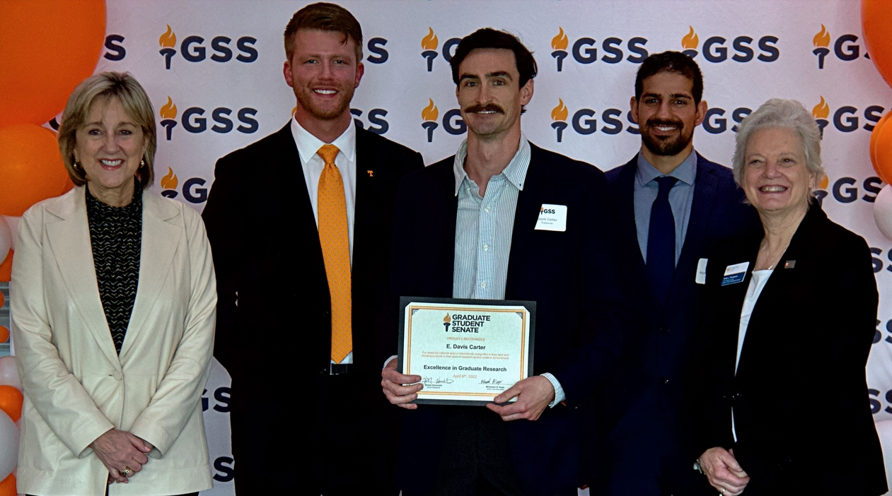
E. Davis Carter – PhD student of Natural Resources with a concentration in Wildlife Health. Davis has published 16 peer-reviewed journal articles and delivered 18 research presentations while playing a critical role in training and mentoring 11 undergraduate students in research. Davis serves as Treasurer, Annual Fundraising Chair, and Justice Committee member for the Graduate Student Senate.

Eliza Baker – PhD student in Veterinary Medicine. Eliza studies diseases of wild carnivores as part of zoonotic disease epidemiology and is a leader in the making with multiple awards and accolades in her young career. Eliza is diligent, persistent, talented, skillful, and a team player and has submitted one manuscript as a lead author while also being awarded a grant through the Graduate School’s Student and Mentor Research Grant program.
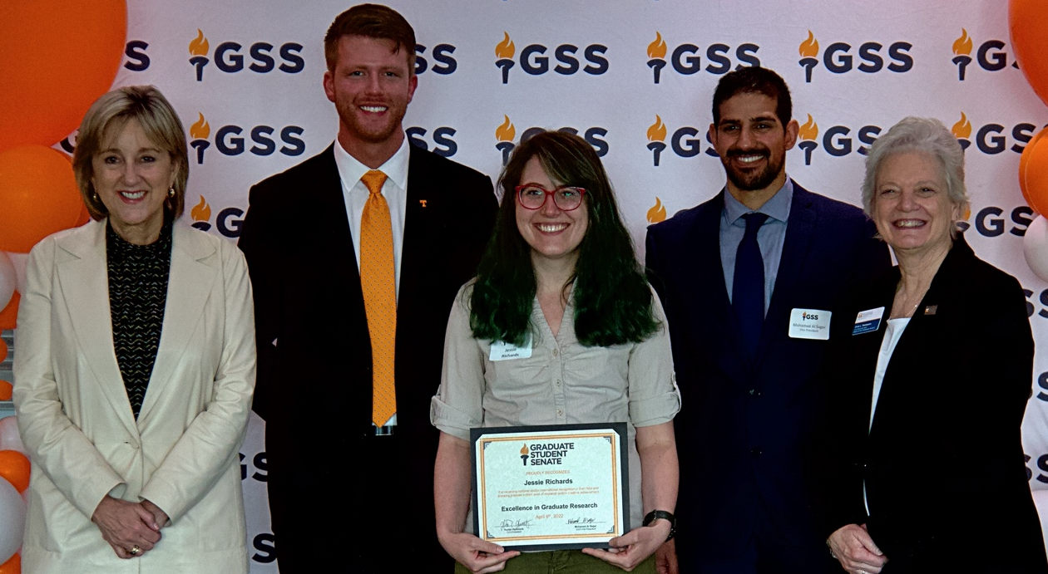

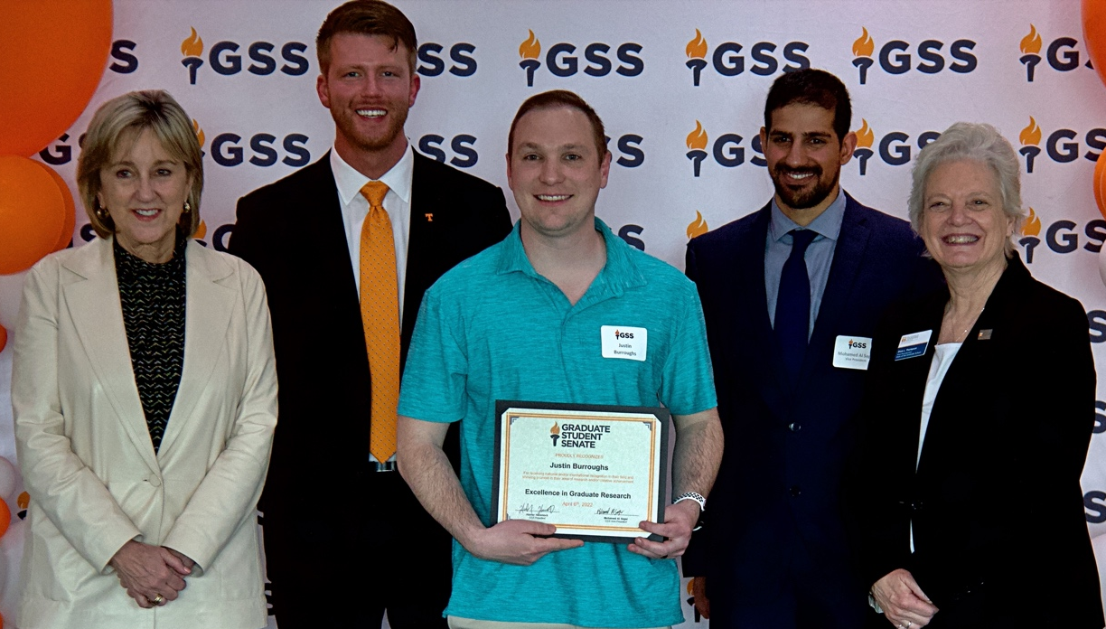
Jessie Richards – PhD student in Veterinary Medicine. Jessie is extremely diligent, persistent, talented, humble, and is a wonderful team player. Jessie has two publications in the final stages of composition and another three she is working one. She is someone who loves research, interacting with people, and solving problems. Jessie’s work has generated much national and international interest, and has developed the only live animal test for finding an extremely important parasite found in domestic and wild animals.

Justin Burroughs – PhD student in Polymer Chemistry. Throughout his education, Justin has worked diligently to receive four peer reviewed publications and has taken it upon himself to go the extra mile to learn about science in other fields of chemistry to better develop his own projects. Justin has served two terms as president of the Association of Chemistry Graduate Students and also serves on the Student-Faculty Interaction Committee: working with chemistry faculty to help develop and improve the culture of the chemistry department.

Laura Horton – PhD candidate in Comparative and Experimental Medicine. Laura has unbridled enthusiasm and never shies away from any assignment or piece of work. She spends long hours in the field and laboratory and accomplishes her work with overwhelming love, excitement, and persistence. She always seeks to maximize her learning and growth as a scientist and has her sights on being a professor.

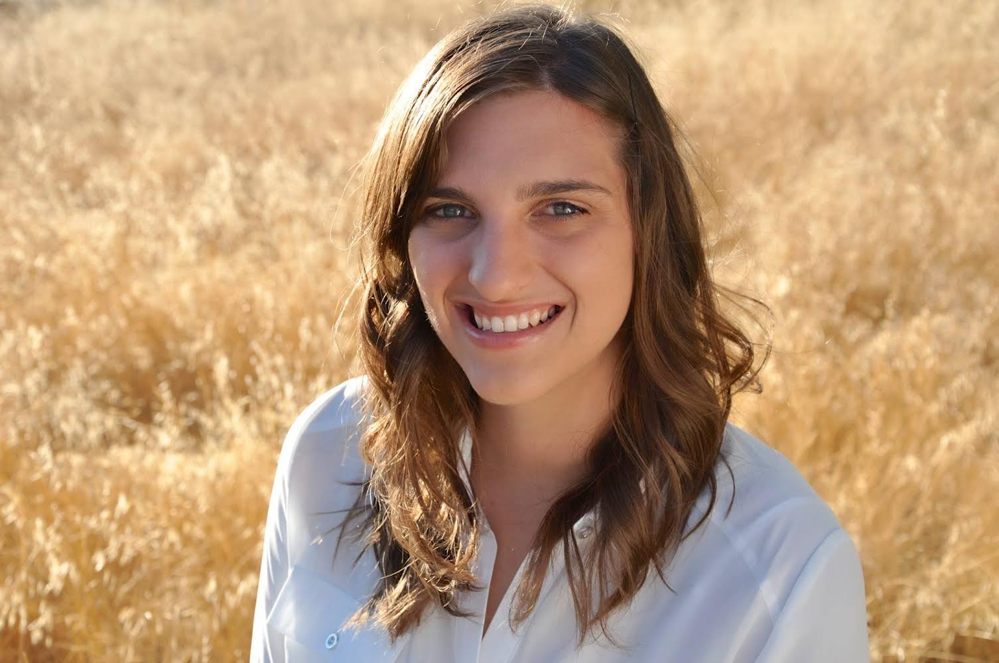

Lauren Beasley – PhD student in sport management in the department of Kinesiology and Sport Studies. Prior to her PhD with UTK, Lauren majored in American Studies and Latin at the University of Texas at Austin and received her Masters of Social Work at the University of Texas at San Antonio. She will graduate in May and begin her new position as Assistant Professor of Sport Administration at Georgia State University.

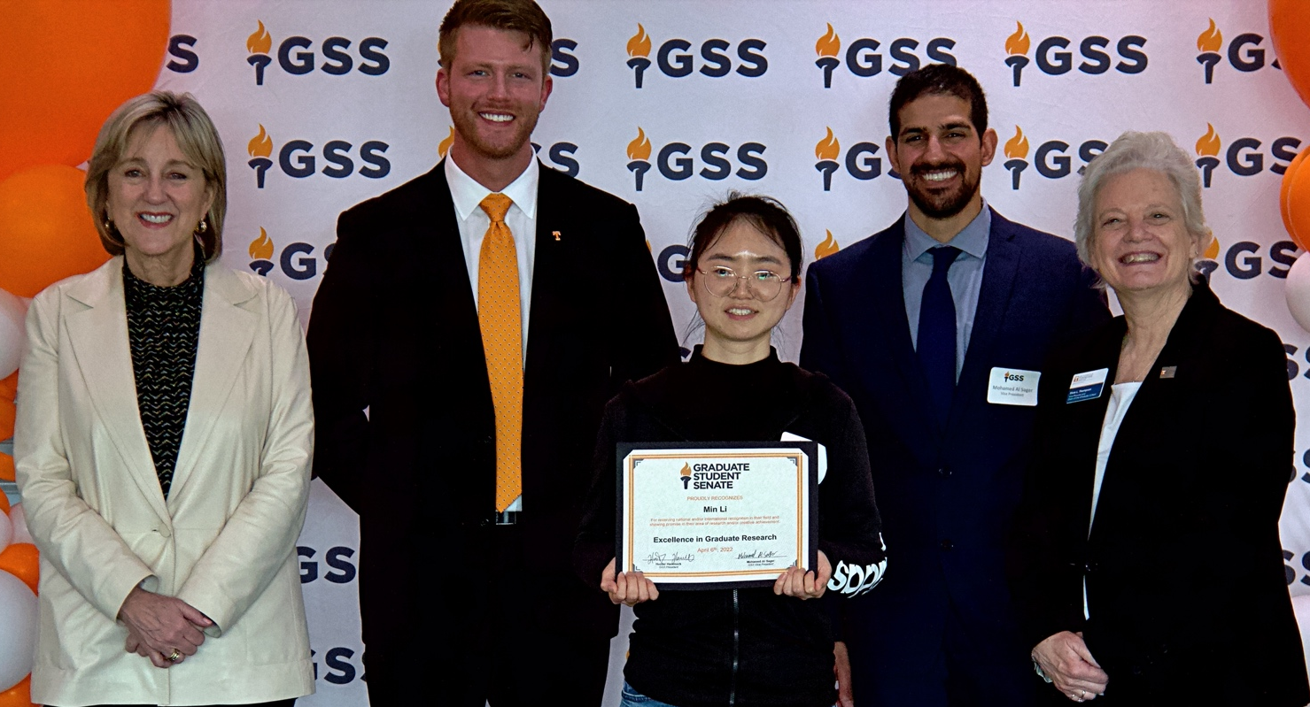
Min Li – PhD student majoring in Food Science. Min Li has achieved significant academic success through out all levels of her education and has produced five academic papers including two as first-author in top journals. Min Li’s work in Biomacromolecules was an invited submission for a special issue where only eight paper were selected globally: editors commenting on her report as ‘state-of-the-art.’

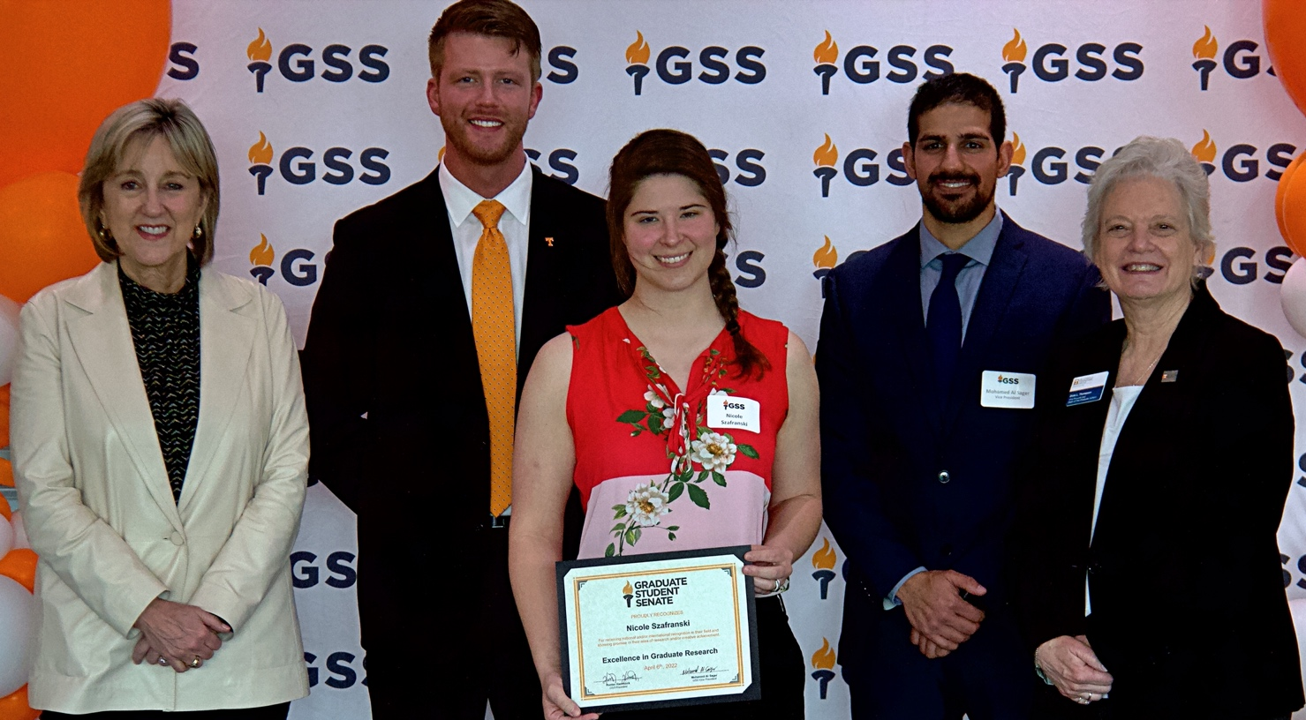

Nicole Szafranaki – PhD student in Veterinary Medicine. Nicole is the first ever resident in parasitology at the College of Veterinary Medicine and is an outstanding student in all aspects including her work ethic, attitude, personality, and research potential. Her research is focused on examining the ecology of T. gondii in waterfowl and implications to wildlife.
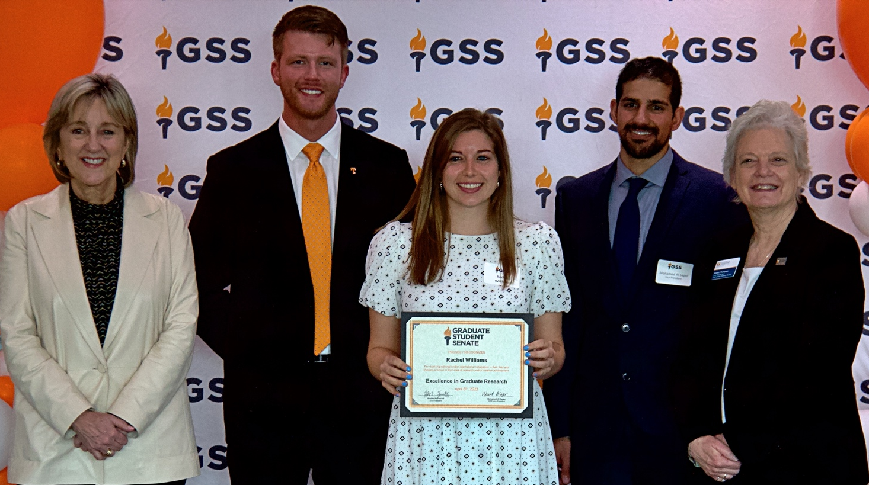

Rachel Williams – Second year doctoral student in Kinesiology and Sport Studies. Rachel is an author on a recently accepted paper in Active Learning in Higher Education that examines course design strategy. She completed the Scholar’s Level Certificate from the Center for Integration of Research, Teaching, and Learning and currently balances data collection and analysis for three projects while also preparing manuscripts for her recently completed work.

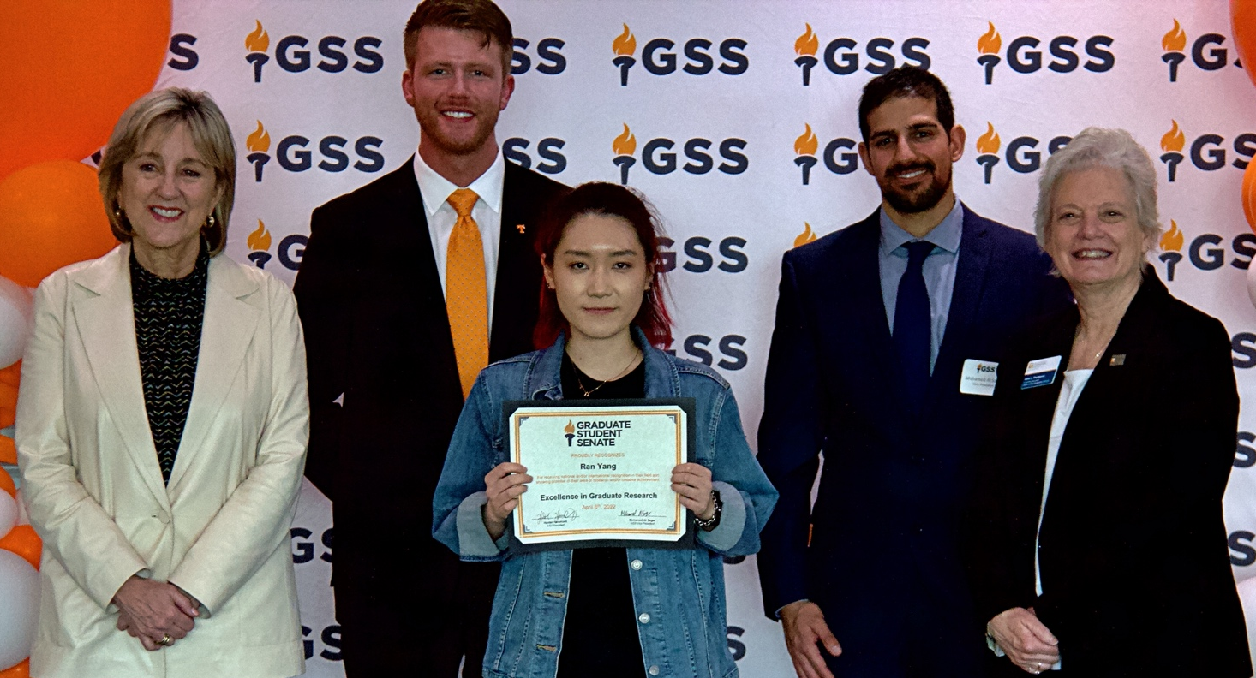

Ran Yang – PhD candidate in Food Science with a minor in Statistics and Data Science. Ran holds a Masters of Science degree in Food Science, has published five peer-reviewed journal articles in top food engineering/science journals, and has won several national and international graduate student awards from professional organizations including first prizes for oral presentation at the Institute of Food Technologists and the International Microwave Power Institute.

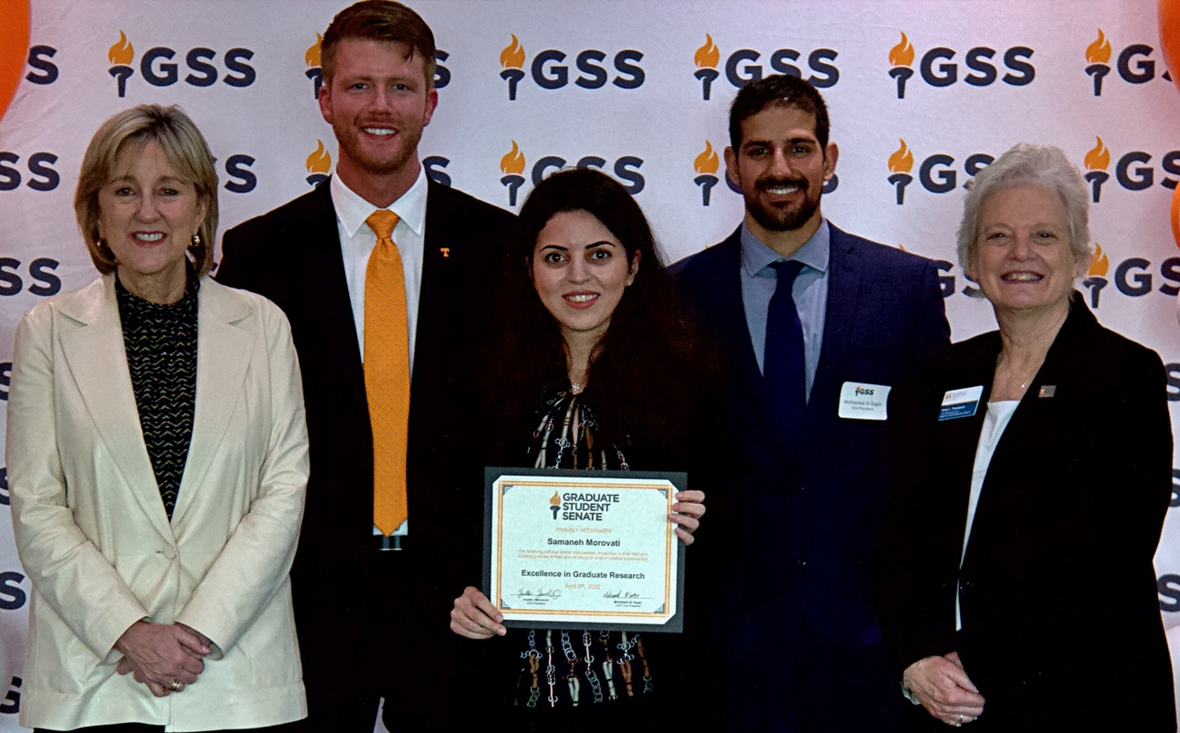

Samaneh Morovati – PhD candidate in Electrical Engineering. Samaneh has a bachelors of science and two masters of science degrees in electrical engineering and has published several papers and posters in top international peer-reviewed journals and conferences. Her main interests include control systems, robust and optimal control, power system dynamics, renewable energy, and smart grids.

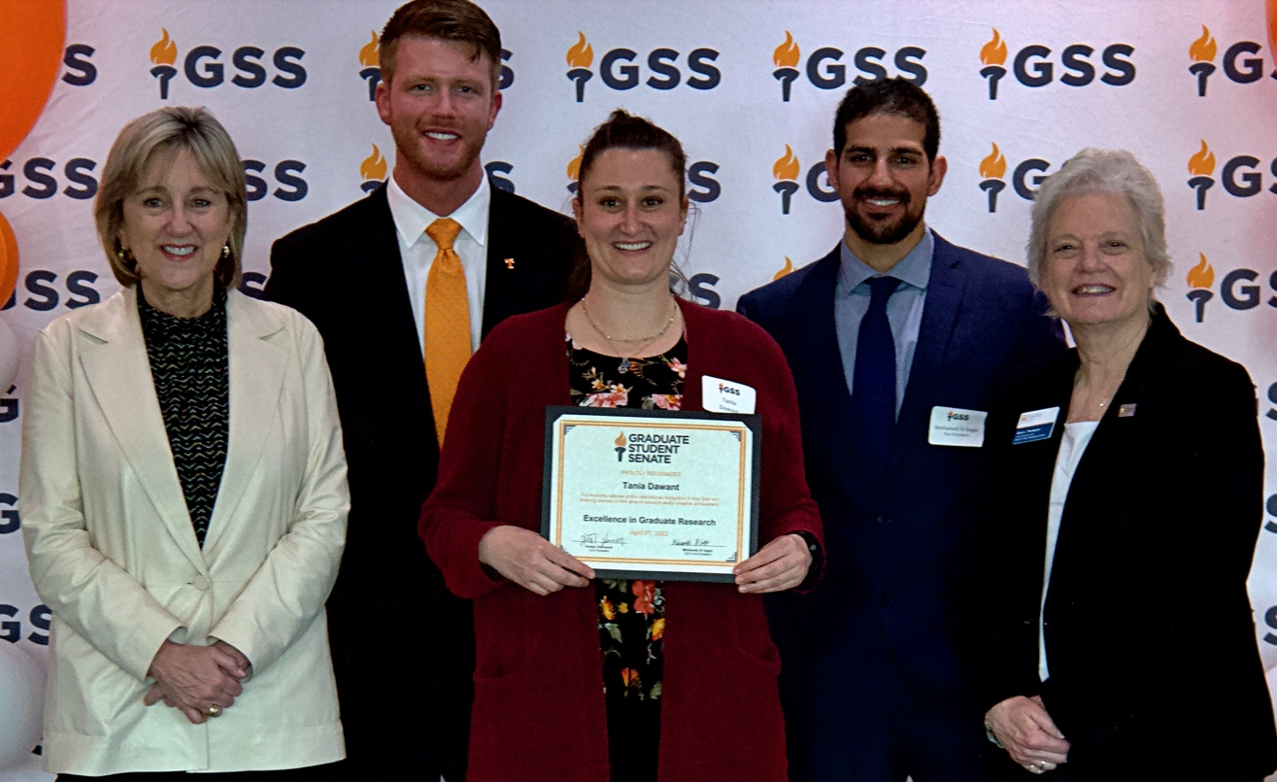

Tania Dawant – PhD Student in Veterinary Medicine. Tania started her PhD this past summer and has already submitted two manuscripts for publication. She has a passion for research as well as wildlife conservation and disease ecology and was winner of the 2020 veterinary school three-minute theses.

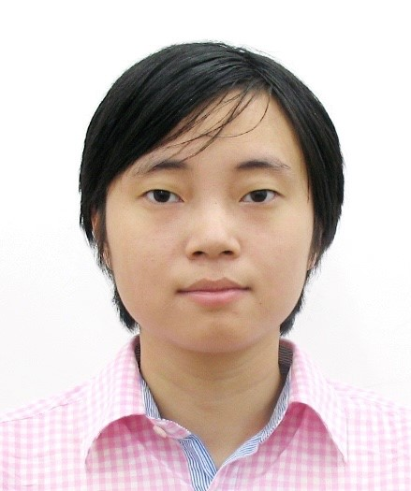

Tianjing Liao – PhD candidate of Political Science. In August, Tianjing will receive her PhD and M.S. in Statistics and has submitted three search articles including ‘Political Protests and The Diversionary Use of Mass Media Evidence from China,’ coauthored by Dr. Hwang, which has been conditionally accepted in International Interactions, a leading interdisciplinary journal.

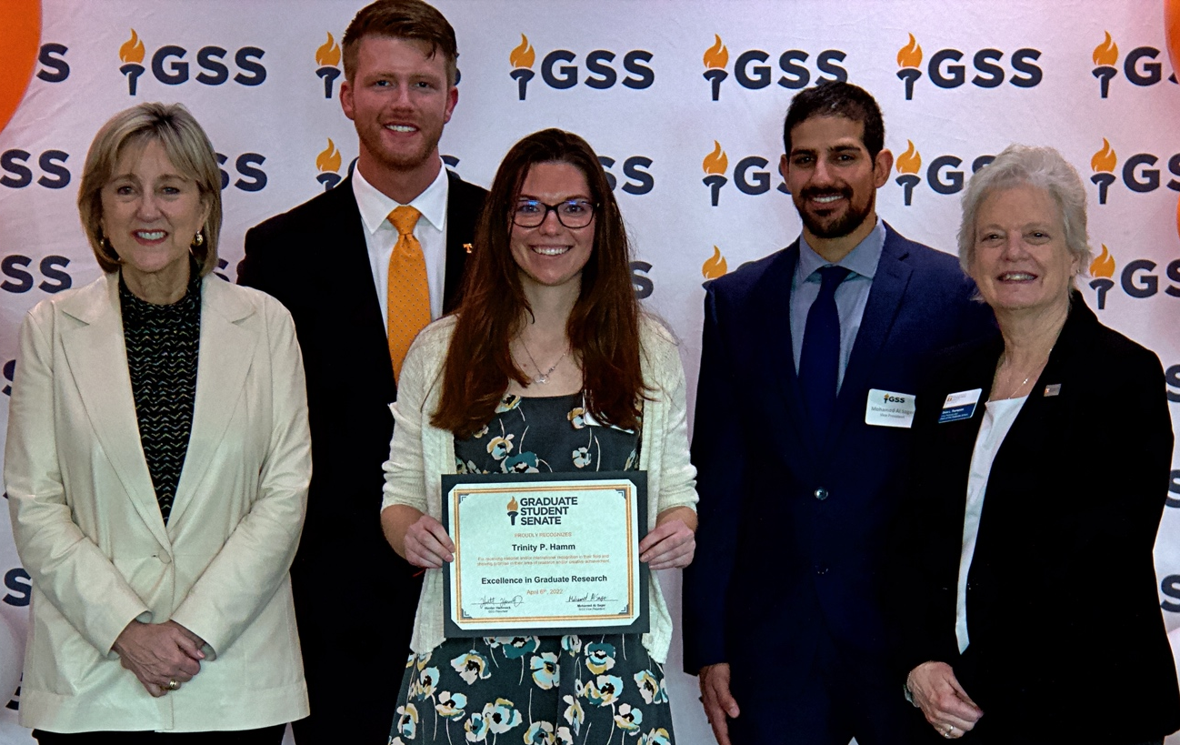

Trinity Hamm – PhD student in Entomology, Plant Pathology & Nematology. Trinity is originally from Pennsylvania and has traveled around the U.S. with her family with a curiosity and passion for plans. She joined Dr. Trigiano’s lab in 2019 to pursue as Master’s of Science in her field of study in which led to her pursuing her PhD. Her dissertation project aims to develop genomic resources for north american flowering dogwoods as well as for its sister specie, asian dogwoods.
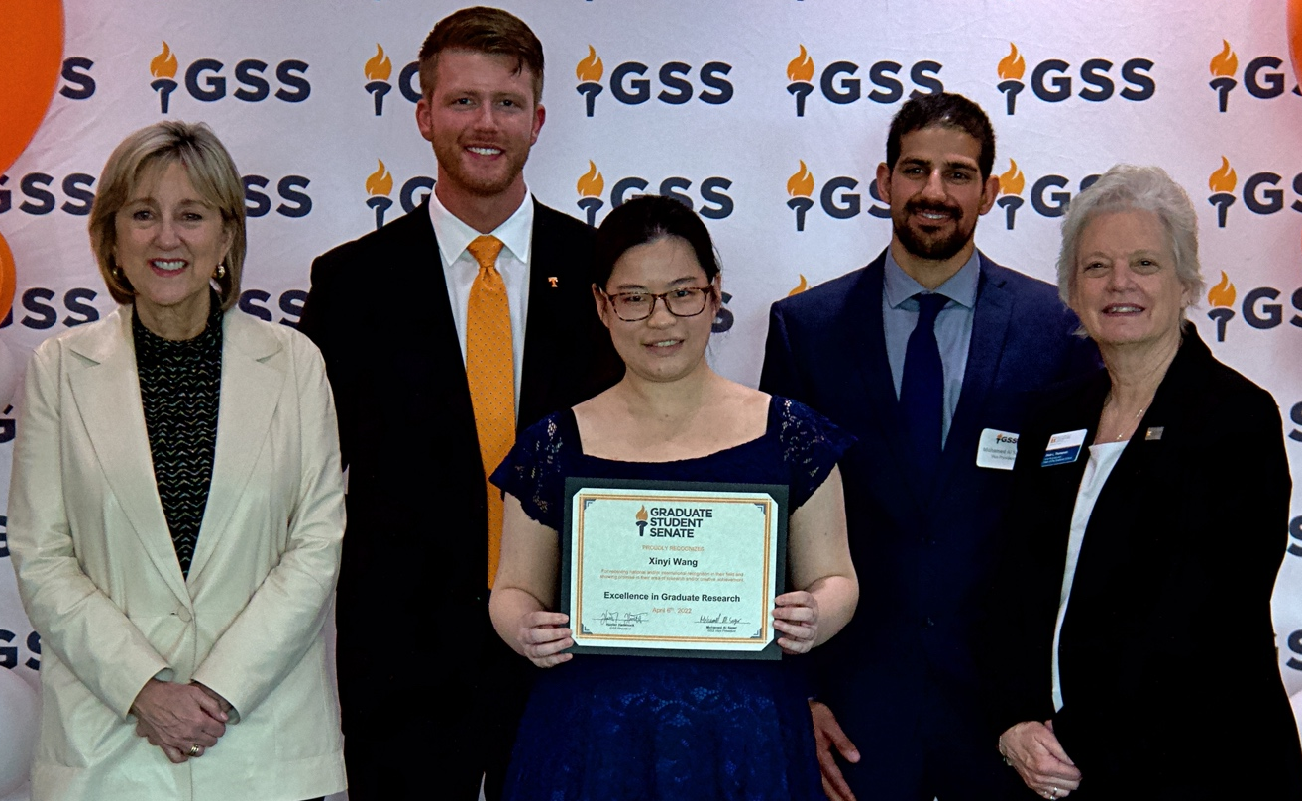

Xinyi Wang – PhD candiate in the department of Chemistry. Xinyi possesses theoretical and practical knowledge in polymer chemistry property relationships and has conducted peer-reviewed research as well as in-person presentations. Xinyi mentors younger researchers and teaches undergraduate organic lab in a safe manner - receiving high-quality assessments from both students and coworkers.

Excellence in Graduate Teaching

This award is presented to graduate teaching assistant and associates for extraordinary performance in teaching.

Awardees:

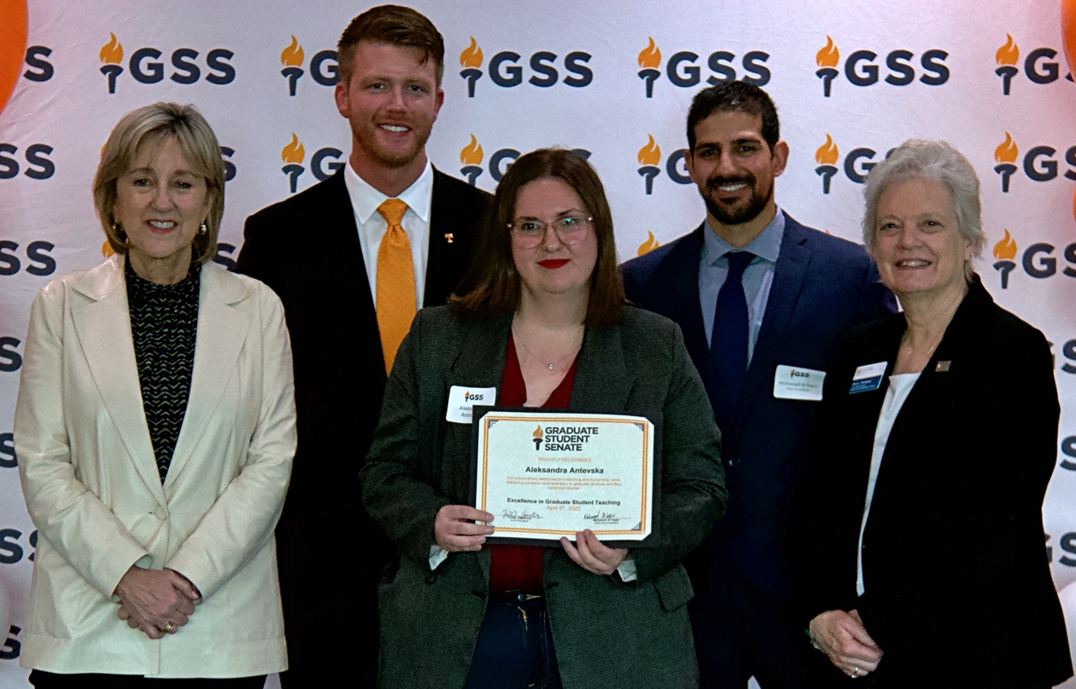

Aleksandra Antevska – Chemistry student and head teaching assistant for Chemistry 132/133. Aleksandra strives to deliver the best quality of material to her students and other TAs by creating an environment for everyone to freely contribute ideas and ask questions. Aleksandra takes the time to meet students' level of understanding and does her best to bring them to the next level.

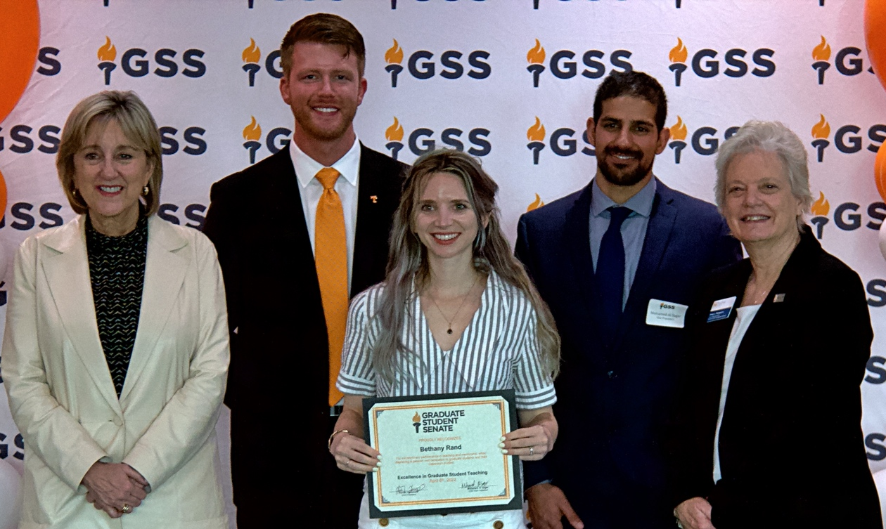

Bethany Rand – Second year doctoral student in the Department of Public Health Sciences. Bethany has served as a graduate teaching assistant for a number of courses including an undergraduate introductory to epidemiology course as the first doctoral student in the department to be an instructor of record prior to achieving candidacy.

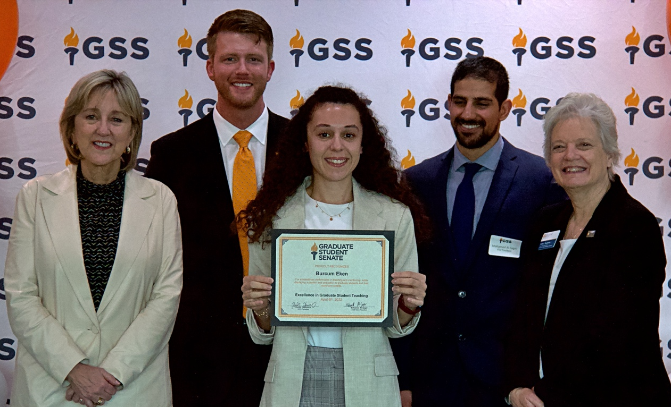

Burcum Eken – Masters student in Computer Engineering. Burcum has a wide range of experiences including serving as an intern under the Turkish Armed Forces Foundation, taking part of a national operating system project called PARDUS, and has been involved in numerous organizations including Linux Summer Camp, Hacktrick, and the Cyber Security Research and Development Group. Burcum also is co-founder in the Computer Science Security Research and Development Group and was selected to be a pilot in the Coast Guard Academy. She was also volunteer instructor in a project organized in cooperation with CISCO- Habitat to bring refugees into society in Turkey.

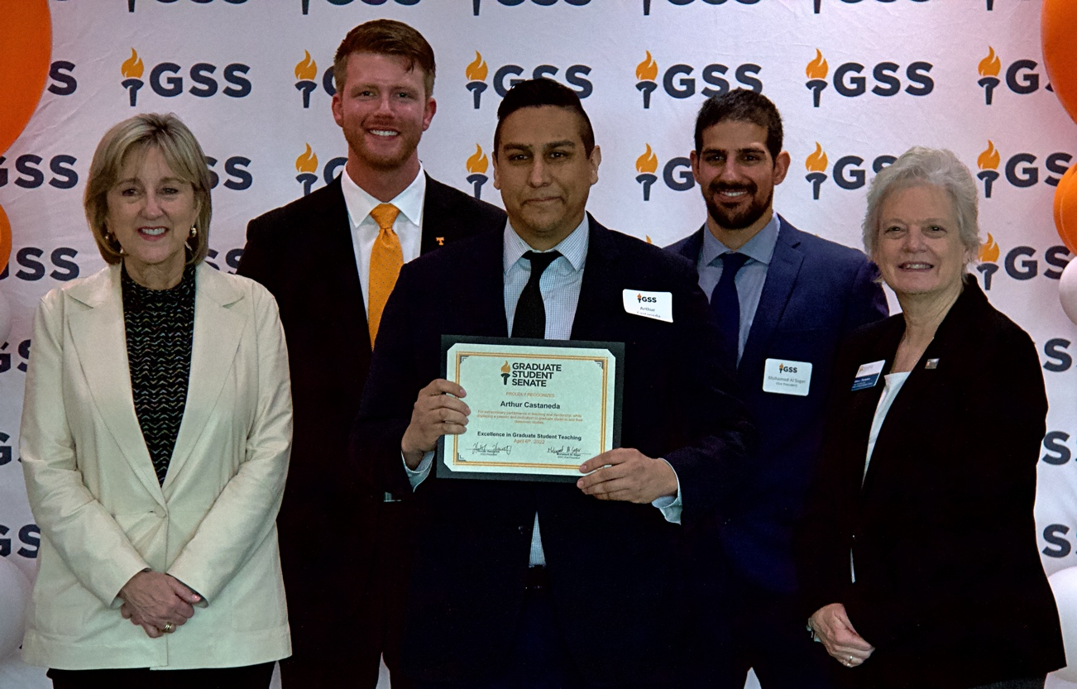

Arthur Castaneda – Fourth-year doctoral student and teaching assistant in Psychology. Arthur has been an excellent TA in numerous courses with his greatest impact as instructor of record for Brain Science Applications. In his first offering, his average student rating from 60 students was a perfect 5 as he has been consistently described as one of the most caring instructors students have ever had.

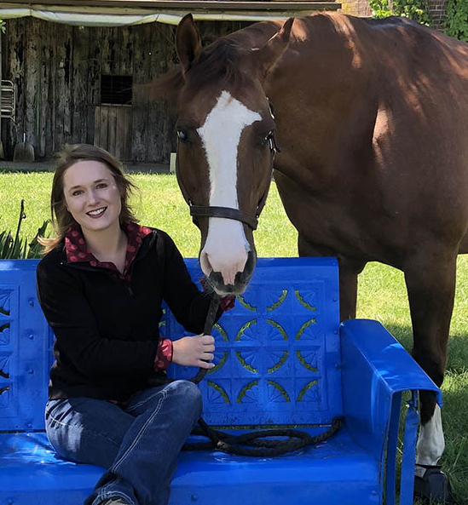

Delaney Rostad – Masters student in Animal Science. During undergrad, Delaney competed on Middle Tennessee State’s collegiate riding team, horse judging team, and stock horse team while majoring in Animal Science with a minor in Spanish. While currently completing her Masters degree, Delaney is a coach of UT’s equestrian team as well as for a middle school and high school equestrian team.

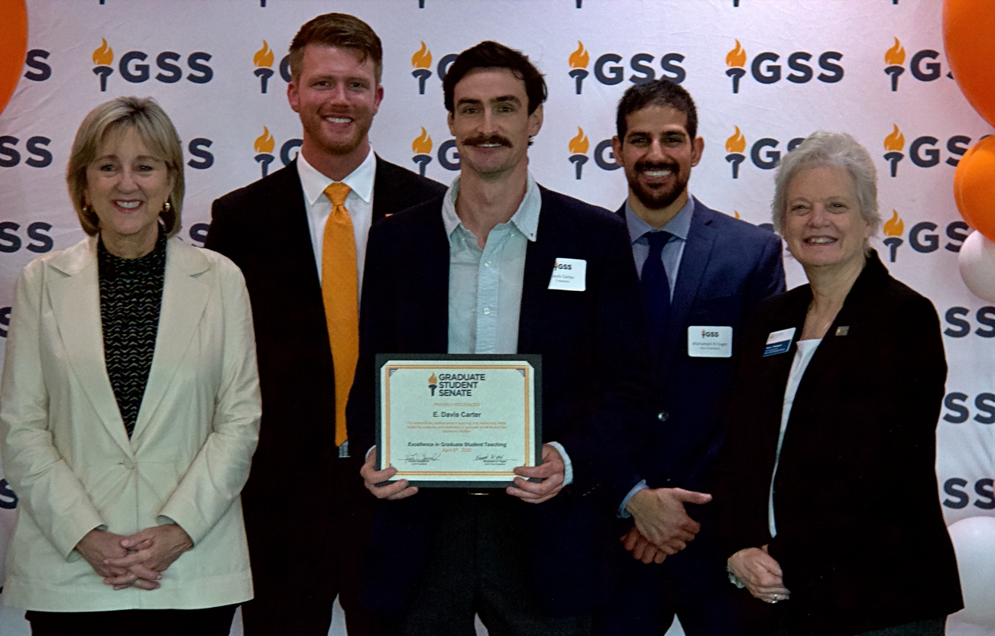

E. Davis Carter – PhD research assistant in Natural Resources. Davis has participated in teaching six UT courses: two of which he was a co-instructor for three years. Davis has been responsible for organizing course activities, scheduling and delivering lectures, developing active learning assignments, leading field trips for experiential learning, organizing study sessions, and creating quizzes and exams.

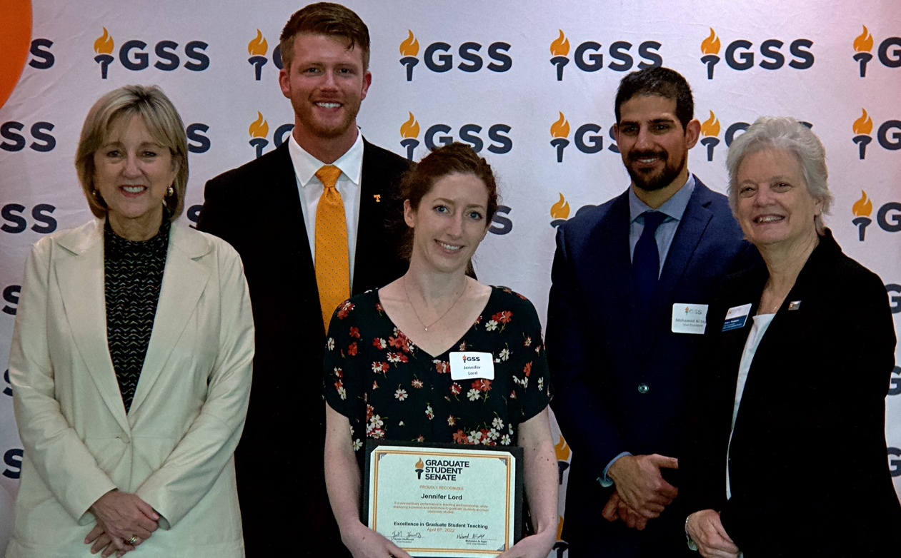

Dr. Jennifer Lord – Dual degree PhD student and graduate teaching assistant in Epidemiology (MS in Statisitcs). Dr. Lord is a brilliant, motivated hard-working, curious, respectful, and well-disciplined individual who teaches and mentors GIS and Geographical Epidemiology courses who goes the extra mile to help students with a smile.

Jeremy Kourvelas – Master of Public Health student and graduate teaching associate. Jeremy has served as Vice President of the Public Health Student Association, organized events that have brought together multiple graduate departments and community stakeholders, written policy briefs on substance use disorder for the SMART Policy Network, and published guest editorials in the Tennessean on issues of healthcare and the environment. Jeremy encourages open dialogue on difficult topics in his classroom, particularly as it pertains to healthcare finance reform.

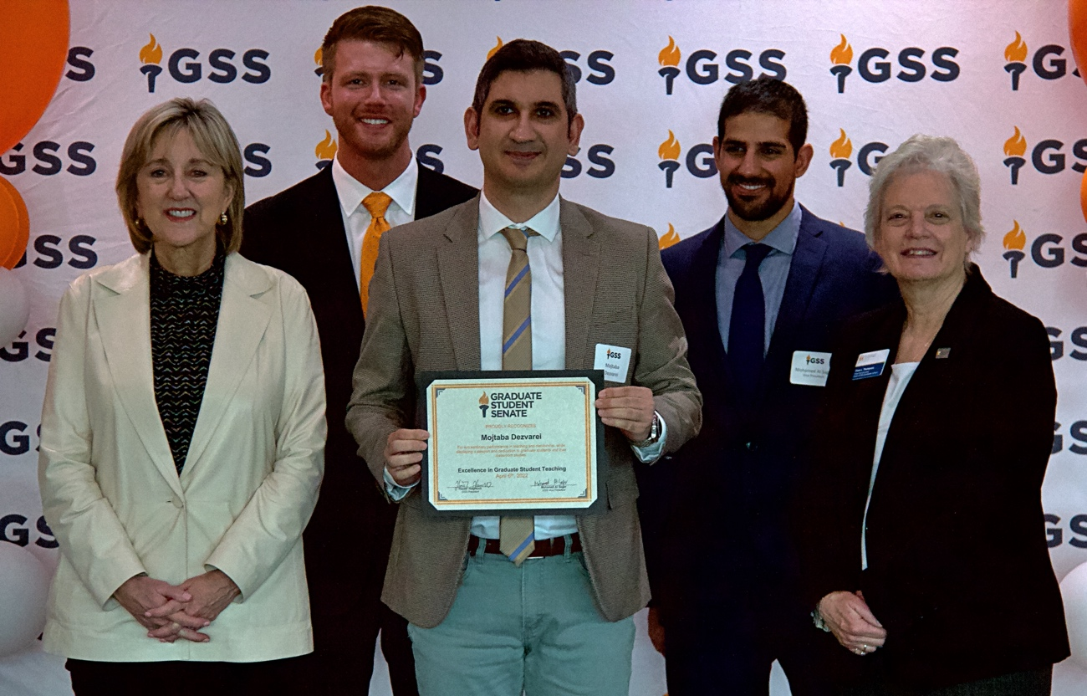

Mojtaba Dezvarei – Ph.D. student, graduate research and teaching assistant in Electrical Engineering. Through research, Mojtaba has defined a new defense mechanism for short-load forecasting to reinforce power system against incident presenting at the IEEE Power and Energy Society General Meeting in 2022. His main research is to employ machine learning methods to enhance power system control, operation and planning to maintain its reliability and resiliency.”
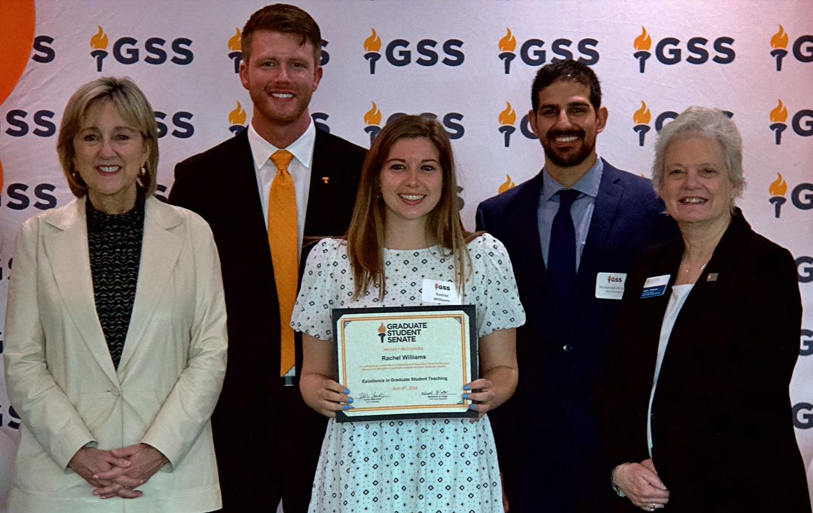

Rachel Williams – Second year doctoral student in Kinesiology and Sport Studies. As lecturer in KNS 290, Rachel quickly earned an incredible reputation among students as she is unparalleled in her deliver of information using evidence-based tactics to stimulate engagement and critical thinking.In her first year of doctoral studies, Rachel earned the Hobt Memorial Teaching Award for being the highest rated instructor in the Physical Education and Activity program by her students.

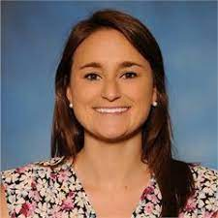

Wesley Sheley – PhD candidate and graduate research assistant in Comparative & Experimental Medicine. Wesley is co-instructor for two wildlife health courses in which she leads with seamless effort. Besides teaching, Wesley serves as a mentor for students in designing and conducting research and has also guided presentations at professional conferences.

Excellence in Service

Description: Award presented to graduate and professional students who are extraordinary campus leaders, participate in service learning or other community initiatives, and/or provide service leadership to their academic discipline through service in professional organizations

Awardees:

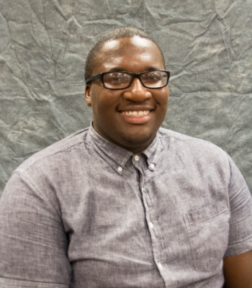

Avery Blockmon – Fifth year PhD student in the Department of Chemistry. Avery is President of the Multicultural Graduate Student Organization and resurrected the organization following the coronavirus shutdown. Avery helps bring together students of all demographics and backgrounds and makes them feel welcome in a place far from home.

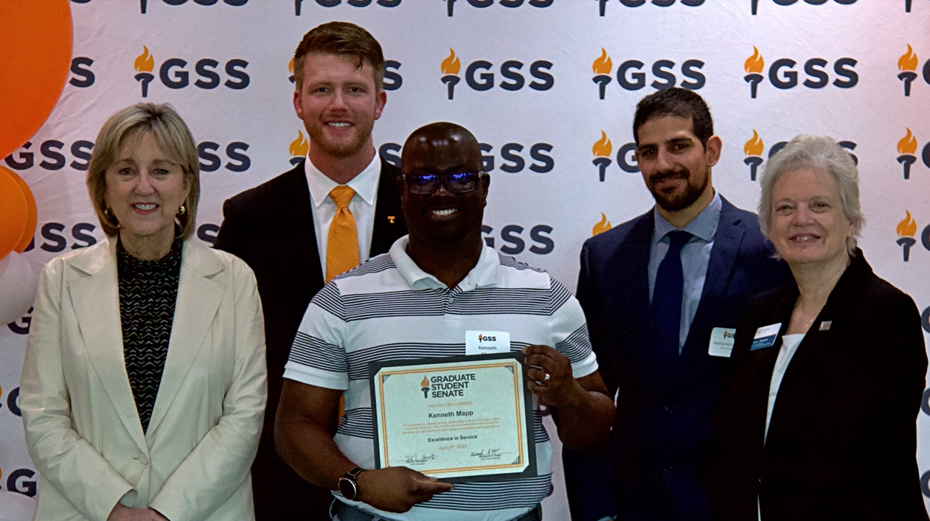

Kenneth Mapp – Second year MPH student in Public Health. Kenneth is involved in two internships, an assistantship, and community service and has served as co-chair of the Public Health’s Diversity, Equity, and inclusion committee. Kenneth’s humility and humor serve him very well in exploring challenging topics and creating a safe space for the exploration of others.

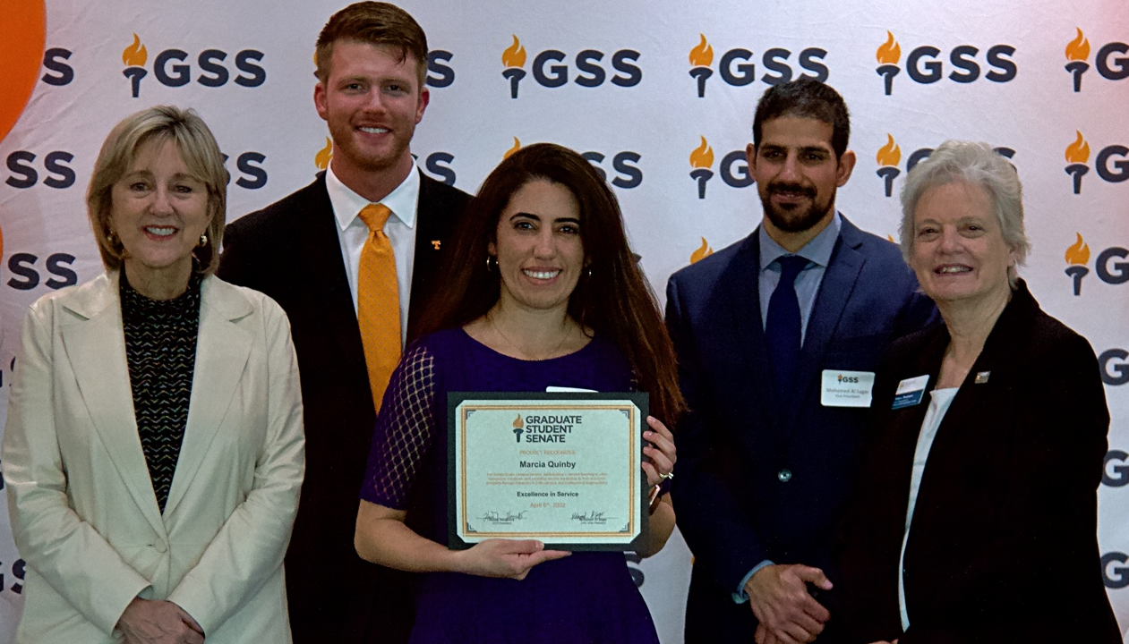

Marcia Quimby – PhD candidate in Plant, Soil, & Environmental Sciences. Marcia is president elect for the honor society Gamma Beta Phi. As president, Marcia initiates and participates in volunteer efforts to help the Knoxville community including trash clean-up on Cumberland Avenue, participation with the YMCA community gardens, and food distribution with the FISH Hospitality pantry that provides groceries for over 7,000 families in the Knoxville area each month.

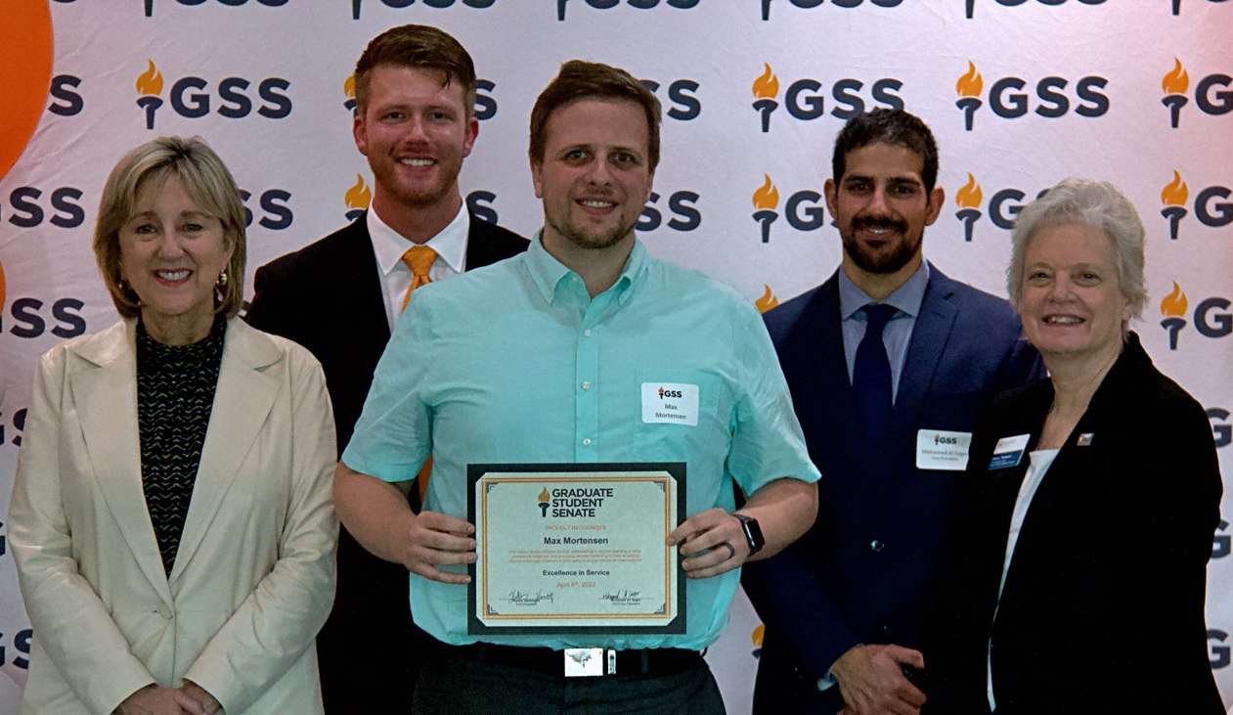

Max Mortensen – Graduate student and graduate teaching assistant of Chemical Engineering. Max volunteers numerous hours to help the local American Institute of Chemical Engineers chapter and produces quality research while raising a family.

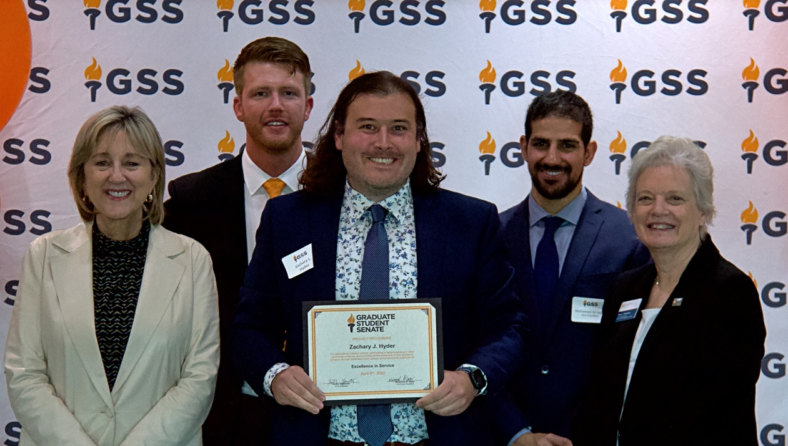

Zachary J. Hyder – Second year doctoral student in Higher Education Administration. Throughout his course work, Zachary as worked in partnership with Student Life, serves as an applicant reviewer for the undergraduate Vol Impact Academy, and also serves on the membership and technology committees of the Education Law Association.

GSS Student Organization of the Year

Description: Award recognizes graduate and/or professional student organizations or councils for their extraordinary contributions to graduate student life or to their respective academic department or program

Awardees:

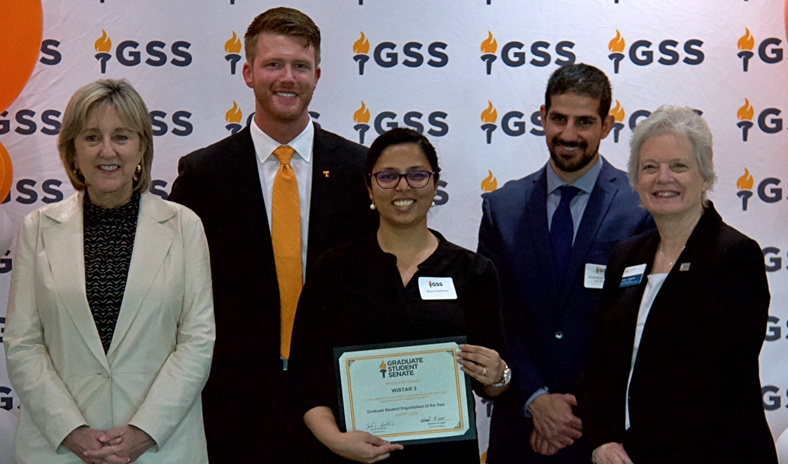

WISTAR 3 – WISTAR3, standing for Women in STEM Advancing Research, Readiness, and Retention, is an organization that specifically focuses on the needs of graduate women in STEM fields. Throughout the year, GSS and WISTAR3 collaborated on numerous events including a highly successful salary negotiation workshop in February with Dr. Nina Fefferman and Dr. Debra Miller. GSS would like to thank WISTAR3 and looks forward to continue collaborating on beneficial events for graduate students.

Graduate Research Mentor of the Year

Description: Award recognizes faculty or staff members who have shown outstanding commitment to mentoring graduate research students

Awardees:

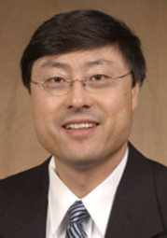

Dr. Bin Hu – Professor in the Department of Materials Science and Engineering. Dr. Hu’s research group has an incredible track record of producing phenomenal scientists as his group is highly collaborative and seeks out to solve fundamental questions in semiconductor physics. His students have gone on to become staff scientists and post doctorates and have shown to be highly productive publishers in high impact journals including three in the past year with high counts of first authorships and high impact work.

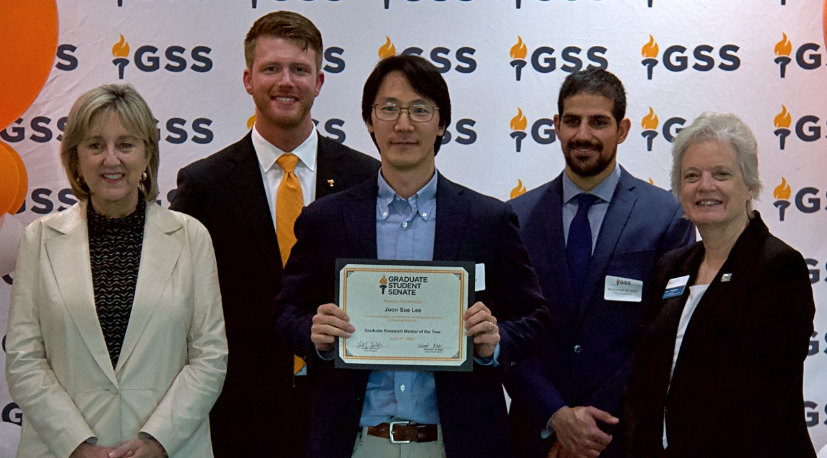

Dr. Joon Sue Lee – Assistant Professor in the Department of Physics and Astronomy. Dr. Lee received his PhD from Penn State University in 2014 and served as a postdoctoral researcher prior to arriving at UTK with Penn State and the University of California, Santa Barbara. Dr. Lee provides motivation and optimism to his students and always starts a conversation with a smile and a positive note.
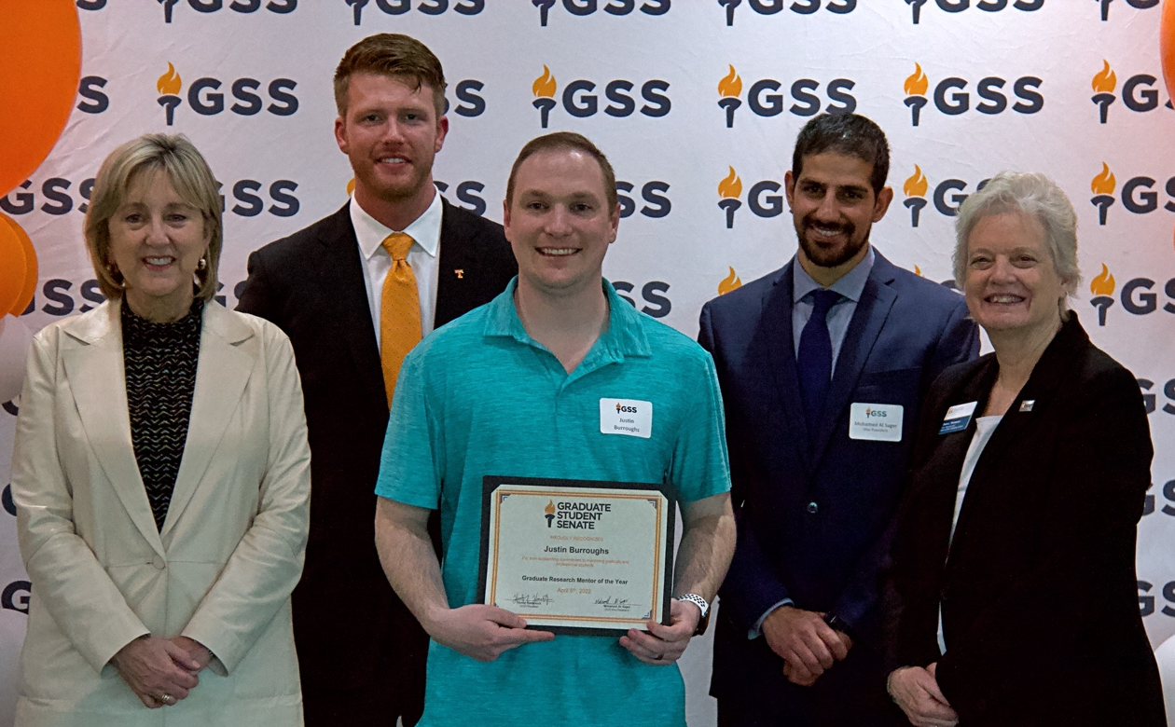

Justin Burroughs – Graduate teaching assistant in the Department of Chemistry. Justin always goes above and beyond his repsonsibilites to help others and even goes out of his way to mentor students both within and outside of his group. Justin is a model upper-classman graduate student who is generous, encouraging, and insightful.

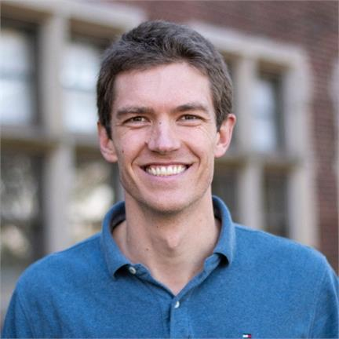

Dr. Mark Wilber – First year assistant professor in the Department of Forestry, Wildlife and Fisheries. Dr. Wilber has served on several graduate student committees and has been amazingly supportive in helping guide and mentor several graduate students through different portions of their program. He is currently mentoring and advising his own PhD student and developing their ability to pose, investigate, and answer well-defined research questions by providing academic, professional, and financial support.

Sarah Boggess – Laboratory coordinator in the Department of Entomology and Plant Pathology. Sarah is a native Tennessean and UT grad that plays a crucial role in organizing the Trigiano Lab and mentoring incoming lab members. Her work extends to undergraduate researchers, graduate students, post-doctoral students, and various collaborators. She fosters a productive lab environment where student can grow and innovative research can be conducted.

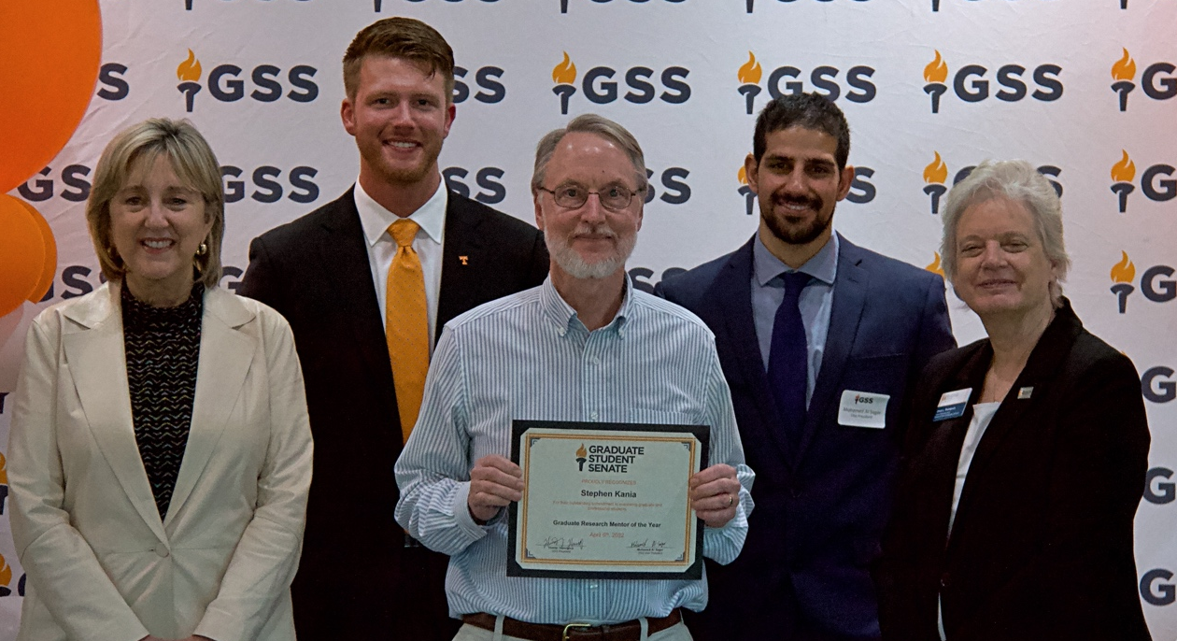

Dr. Stephen A. Kania – Tenured professor and assistant dean for research and graduate studies in the Department of Biomedical and Diagnostic Sciences. Dr. Kania serves as a major professor for eight PhD candidates and one master’s candidate at the University of Tennessee as well as two PhD candidates in programs in Egypt. Dr. Kania’s career is dedicated to advancing the science of microbiology through discovery and training our next generation of scientists.

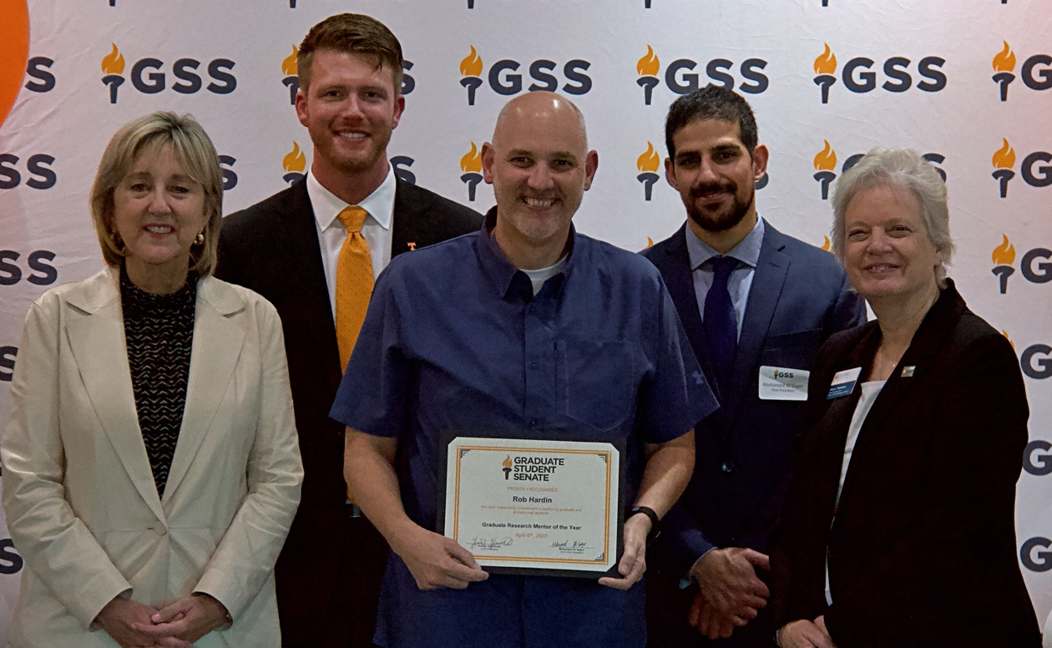

Dr. Rob Hardin – Professor in the Department of Kinesiology, Recreation and Sport Studies. Dr. Hardin is a distinguished scholar and mentor with an impressive publication record of 93 publications as of March. Dr. Hardin has always been extremely active in academic conferences and includes his students in research efforts. In fact, 18 of 20 of Dr. Hardin’s most recent publications include a current or former doctoral student as co-author, and three of those include master’s students, as well.

Graduate Professor of the Year

Description: Award recognizes faculty members who have shown outstanding commitment to teaching graduate and professional students

Awardees:

Mark Wilber – First year assistant professor in the Department of Forestry, Wildlife and Fisheries. Dr. Wilber is co-lead of the modeling team with the Biology Integration Institute, an institute composed of researchers and educators from an array of universities with expertise in research and training on amphibian disease, in which has led to bringing in more than $300,000 to the University. Dr. Wilber’s research combines novel mathematical models, field data, statistics, and laboratory experiments to unravel the contribution of heterogeneity across biological scales to understand disease dynamics.

Graduate Director of the Year

Description: Award recognizes Directors of Graduate Studies who have shown outstanding commitment to mentoring and leading graduate students in their department

Awardees:

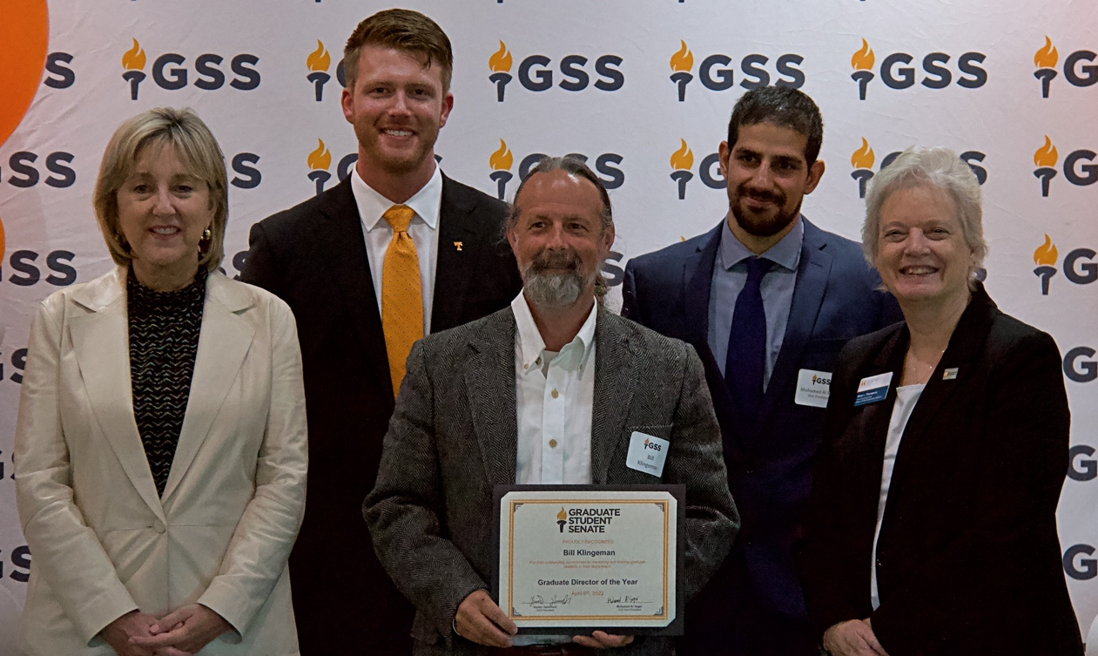

Dr. Bill Klingeman – Professor of Urban Landscape and Production Horticulture Research in the Department of Plant Sciences. Dr. Klingeman serves as Dean of Graduate Studies in the department and goes above and beyond to help graduate students. Dr. Klingeman’s works with projects that emphasize Integrated Pest Management of plants in the urban forest, managed landscape, and nursery production systems.

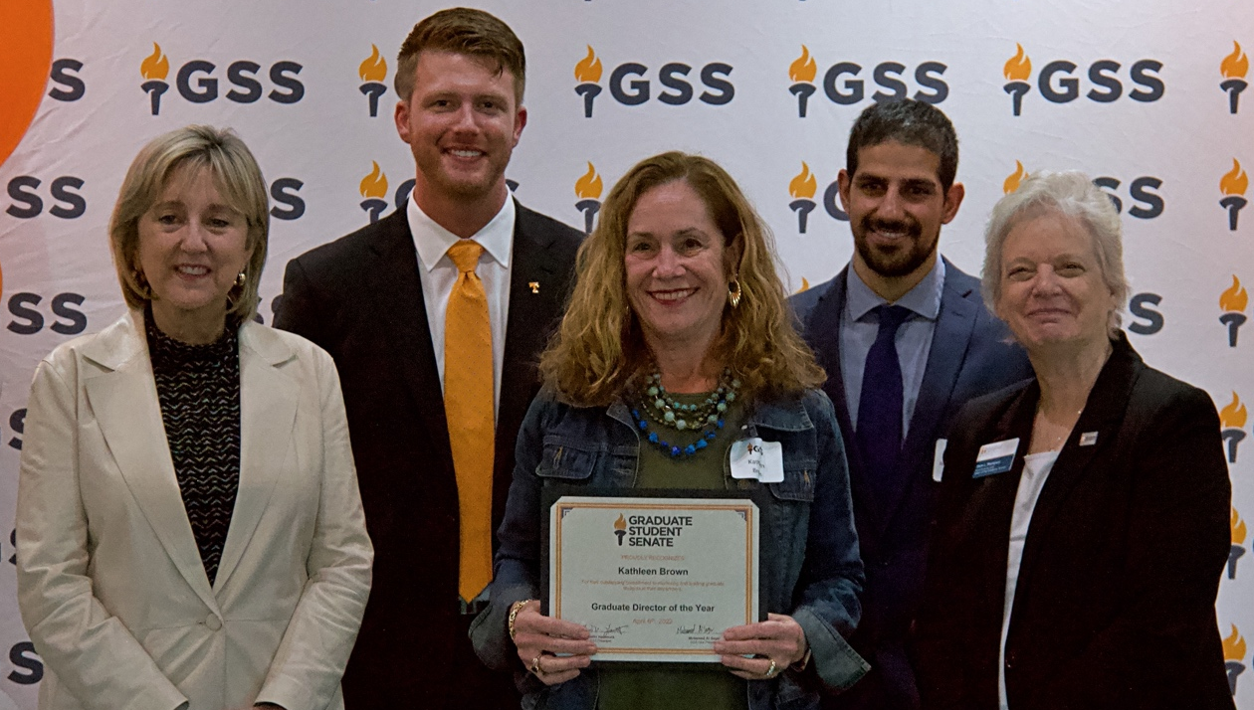

Dr. Kathleen Brown – Director of the Master of Public Health program. Since 2014, the MPH program has flourished under Dr. Brown’s supervision as she has helped increase the program’s concentration offerings from three to five, guided the graduate program through accreditation, extensively revised the program’s curriculum, and has led the development of a distance education MPH degree.

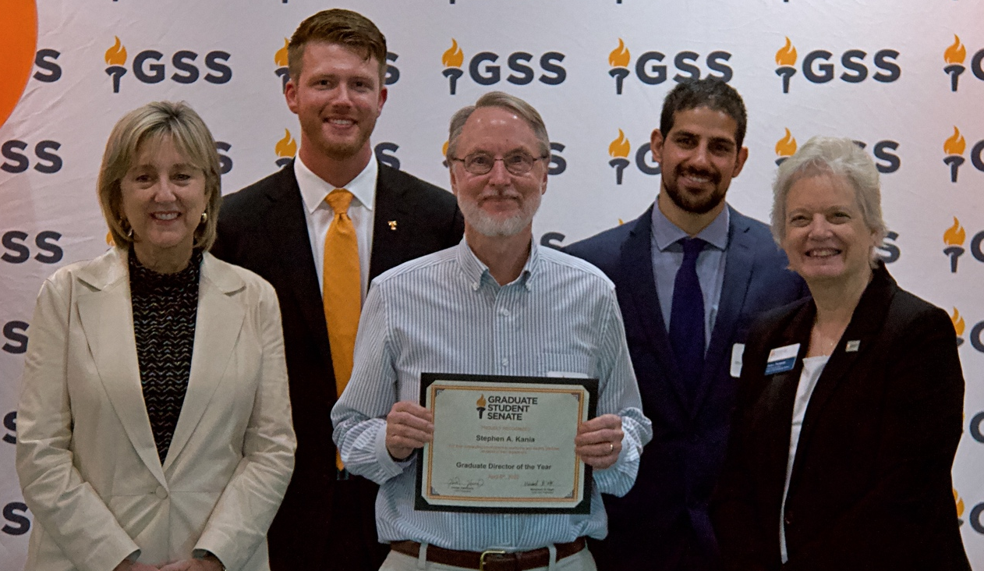

Stephen A. Kania – Tenured professor and assistant dean for research and graduate studies in the Department of Biomedical and Diagnostic Sciences. Dr. Kania has served on 18 PhD committees with students in a diversity of colleges and has over 100 peer-reviewed research publications. Dr. Kania has an additional appointment within the University of Tennessee Genome Science and Technology Graduate program and is an invited speaker for national and international meetings.

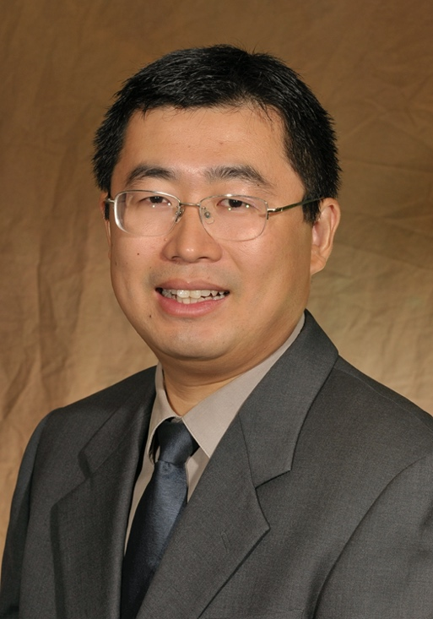

Dr. Yanfei Gao – Professor in the Department of Materials Science and Engineering. Dr. Gao is Director of Graduate Studies in the department and has meticulously set up processes of graduate study and revitalized the curriculum. He carefully plans different avenues to recruiting graduate students and organizes qualifying exams and the graduate affairs committee.

GSS Staff of the Year

Description: Award recognizes a staff member who goes beyond the required duties to ensure that graduate and professional students feel welcome and matriculate successfully

Awardees:

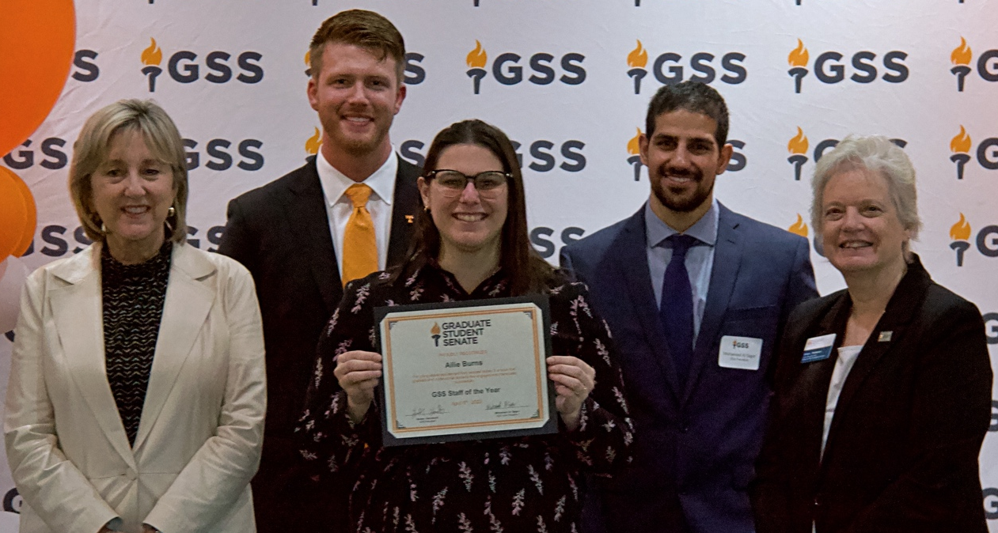

Allie Burns – Academic Engagement Coordinator at The Bredesen Center for Interdisciplinary Research and Graduate Education. Allie meets one-on-one with students to help find resources and to also serve as a confidant for students in need of someone to talk to. Allie coordinates annual retreats for students and faculty and never fails to inform student of important events, opportunities, and deadlines. She truly cares about the success and wellbeing of graduate students and does every possible to make student feel welcome and confident.

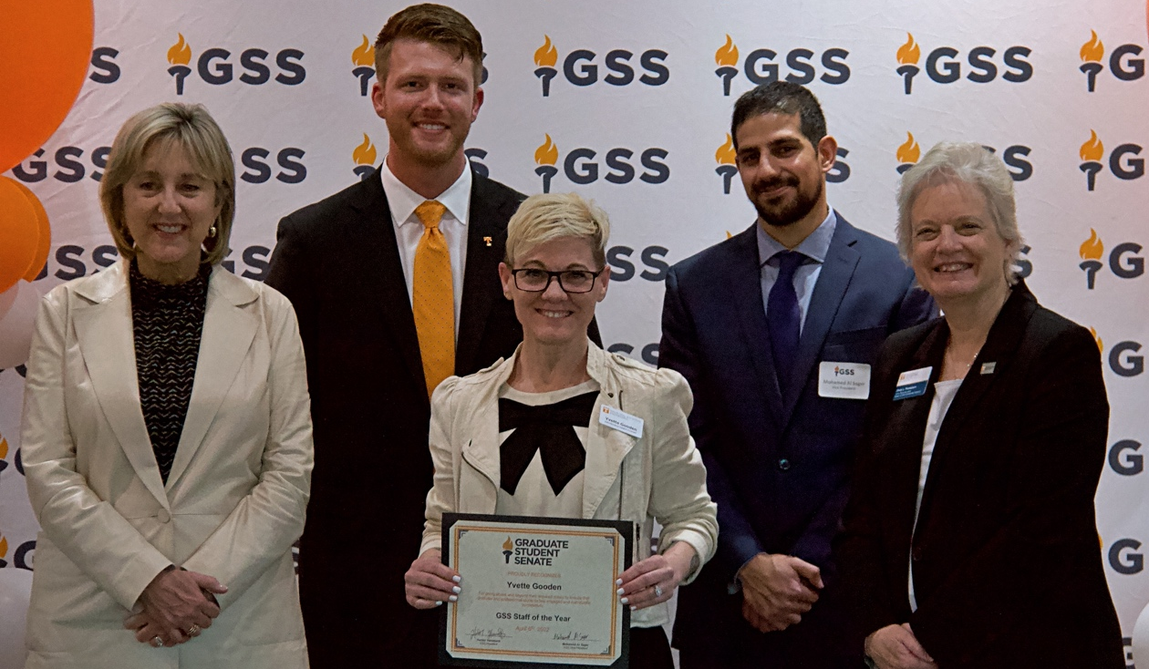

Yvette Gooden – Administrative Support Specialist in the Department of Industrial & Systems Engineering. Gooden is always the first to arrive daily with a warm smile and a happy greeting to co-workers, students, and visitors. She is willing to support and assist her department in anyway she can and won the Tickle College of Engineering Outstanding Staff Award in 2018.

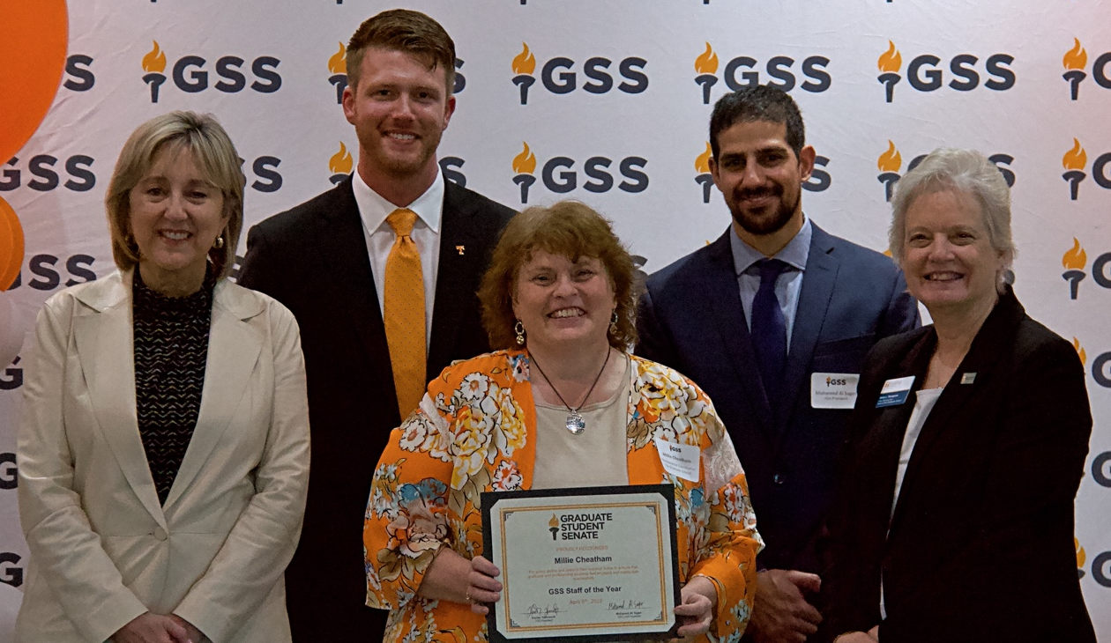

Millie Cheatham – Administrative Coordinator for The Graduate School. She is critical for general operations of the grad school. Hunter and Mohamed both specifically wanted to thank you for your unwavering support these last 11 months. You have been an amazing mentor and vital asset for the Senate. We (along with the grad school) are blessed to have you!!

Gradate Student Senate Outstanding Contribution

Description: Award recognizes student senators and/or members of the GSS executive board who go beyond their regular duties to serve and promote the mission of the Graduate Student Senate

Awardees:

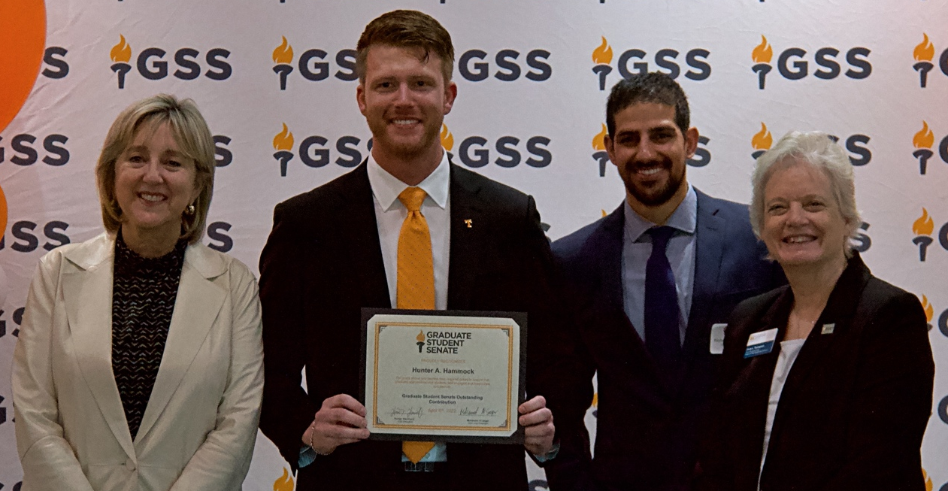

Hunter A. Hammock – GSS president and doctoral student in Plant, Soil & Environmental Sciences. As a member and president of the Graduate Student Senate, Hunter has successfully lobbied for an array of initiatives including graduate student stiped increases, bridging connections between undergrad, grad, and faculty governance by gaining GSS representation on the Faculty senate, and facilitated social reconnection of the graduate student body during resumption of in-person classes following the COVID shutdown.

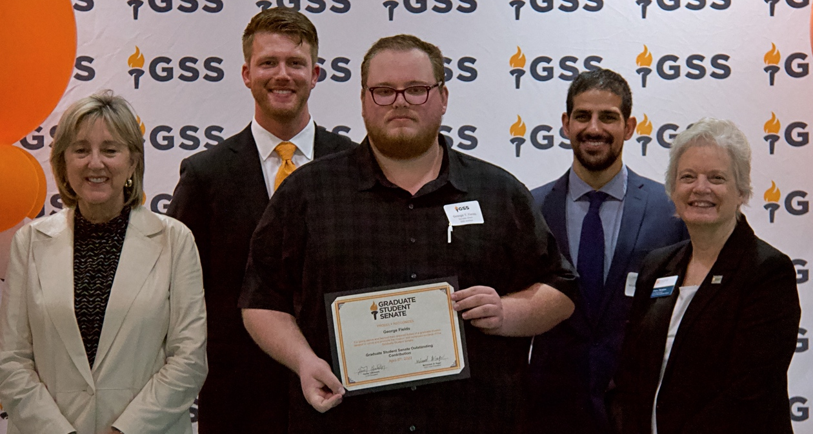

George Field – Third-year PhD student Political Science. George has been an advocate for his fellow graduate students since he started his graduate career in 2018 as he has served in his department’s (Political Science) graduate student organization and as well as the Graduate Student Senate as a Senator, Senate Chair, and a Justice for the 2021-2022 academic year.

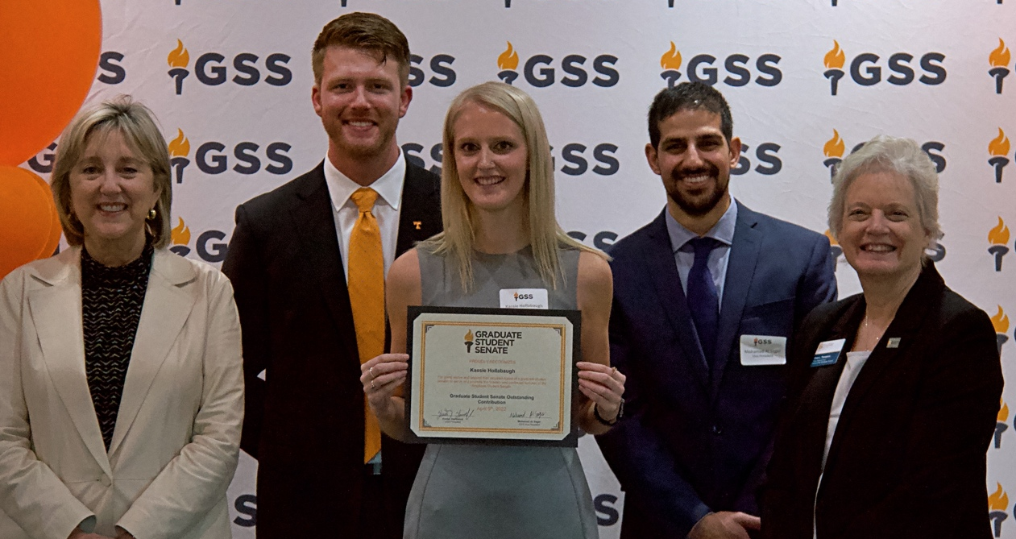

Kassie Hollabaugh – PhD student in Entomology, Plant Pathology, and Nematology. Kassie serves as Travel Awards Chair for GSS and serves as our unofficial photographer. Kassie has worked the hardest of any committee chair or exec team member due to the sheer volume of awards that were required of her position. She sent over 2k emails during the last 10 months in regard to travel awards, in addition to reviewing over 200 applications to date. She has successfully helped to distribute almost 100k dollars to students desiring to present UT research at conferences. We are extremely proud of her service and the major impact it has had on the graduate student body.

